**Peer Evaluation for Lab 7 – Tutorial and Review from Tutorial 13 (HTML)**

|  |  |
| --- | --- |
| Your name: (Your lab is the one being evaluated) | Amanda Akins |
| Name(s) of peer evaluator(s) | Sylvia Rangel |
| Date: | 3/10/16 |

Instructions  
You should have already completed Lab 7. After you and a peer have evaluated your work, you will submit this evaluation along with screen shots indicated in moodle. You may make corrections to your work as a result of the evaluation. Submit only the updated version in moodle and to citstudent.

|  |  |
| --- | --- |
| ***Tutorial*** | |
| Comment at the top of the file contains student name. | Yes |
| After the link element in the head section, a script element is inserted accessing an external js file. ALL JS CODE IS IN THE EXTERNAL FILE? | Yes |
| The solution contains function definitions for the following functions:   * init * setupPuzzle * changeBackground * checkSolution * swapPuzzle * showSolution * peek * unpeek | Yes |
| The external js file begins with a line of code that causes the init function to run when the document has finished loading? | Yes |
| Page runs correctly in primary browser? Screen shots are included?   * Puzzle loads correctly when clicking a puzzle button? * Clicking on a cell changes the background color? * Peek shows red and pink cells briefly and returns to normal? * Show solution cancels based on user input? Show solution displays completed puzzle? | Yes |
| Page has been tested in another browser? Runs correctly and/or errors have been noted? Screen shot is included? | Yes |

|  |  |
| --- | --- |
| ***Review*** | |
| Comment at the top of the file contains student name. | Yes |
| After the link element in the head section, a script element is inserted accessing an external js file. ALL JS CODE IS IN THE EXTERNAL FILE? | Yes |
| The solution contains function definitions for the following functions:   * init * setupPuzzle * changeBackground * checkSolution * swapPuzzle * showSolution * peek * unpeek | Yes |

|  |  |
| --- | --- |
| The external js file begins with a line of code that causes the init function to run when the document has finished loading? | Yes |
| Page runs correctly in primary browser? Screen shots are included?   * Puzzle loads correctly when clicking a puzzle button? * Clicking on a cell changes the background image and font color? * Peek shows errors briefly and returns to normal? * Show solution cancels based on user input? Show solution displays completed puzzle? | Yes |
| Page has been tested in another browser? Runs correctly and/or errors have been noted? Screen shot is included? | Yes |

|  |  |
| --- | --- |
| ***Programming style for all programs*** | |
| Is proper indentation used? | Yes |
| Are comments used appropriately? |  |
| Are variables declared with the keyword var? Do variable names use camel case? (camelCase for example) | Yes |
| Files have been uploaded and tested on citstudent? | Yes |

General comments and notes:

Screen Shots Tutorial:

Chrome (primary):

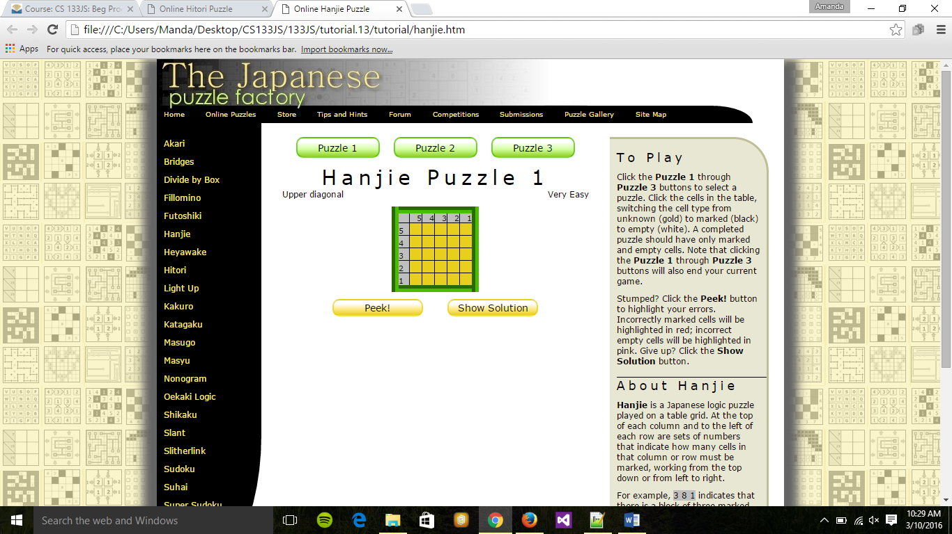

Firefox:

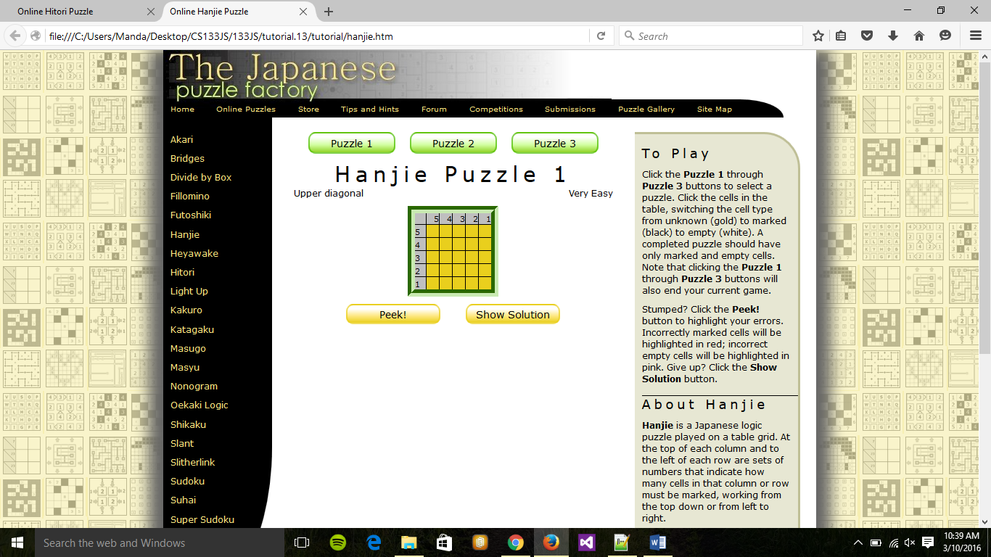

Screen Shots Review:

Chrome (primary):

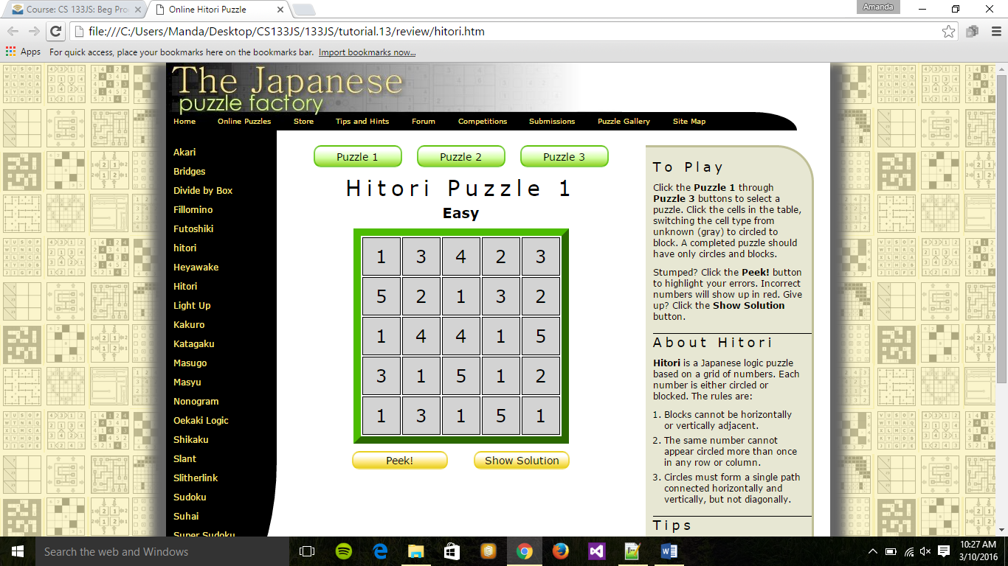

Firefox:

